***Hot working  cold working***

**Hot working Processes:**

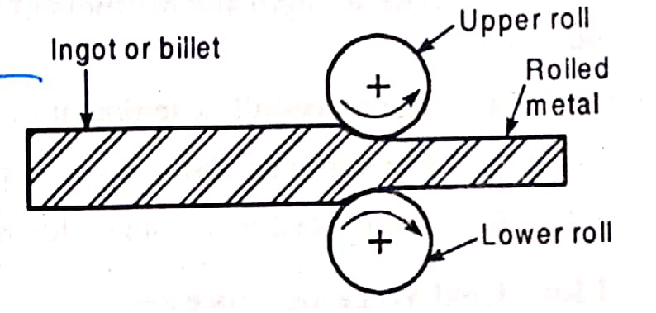

* Rolling.Hot rolling.

* Hot spinning.

* Extrusion.

* Forging.

* Drawing

* Rotary piercing.

**cold working processes:**

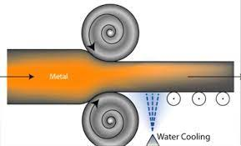

* Squeezing

* Bending

* Shearing

* Drawing